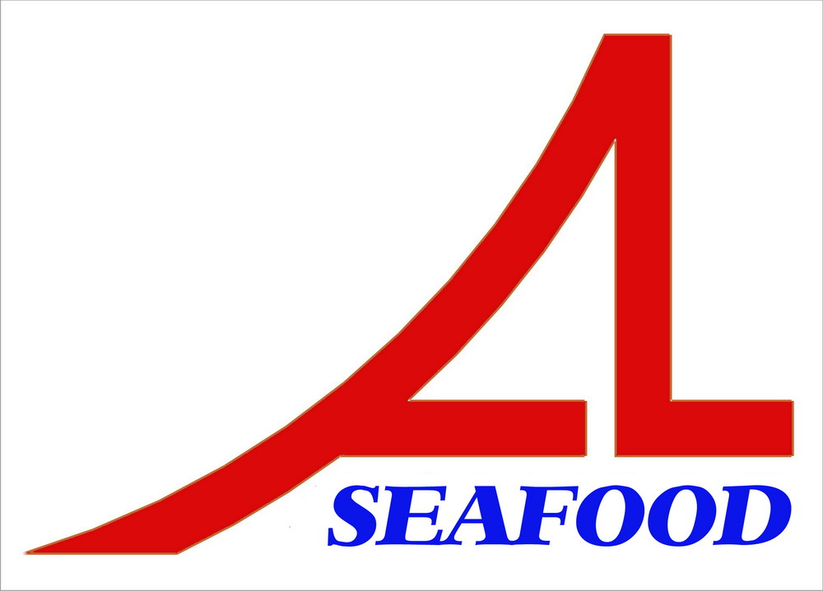AN LAC SEAFOOD CO.,LTD
LOT A14,4A STREET,HAISON INDUSTRIAL ZONE,DUC HOA DISTRICT,LONG AN PROVINCE,VIETNAM

AGREEMENT
Date : 04/10/2013
Party A : AN LAC SEAFOOD CO., LTD.

Address: Lot A14, 4A Street, Hai Son Industrial Zone, Duc Hoa District, Long An Province, Vietnam.

Tel/ Fax: 84-72-3850606 / 84-72-3850608
Represented by: Mr. NGUYEN THIEN DUY – Director

Party B : TOKAI DENPUN CO.,LTD
Address: 24-15 Tenma-cho, Aoi-ku, Shizuoka, Japan
Tel.: 54-253-8730 Fax: 54-205-0187
Represented by: Mr. YUSHU KE YATERA – Director

After discussion , it is must be mutually agreed by both parties to sign for agreement as follow :
Article 1: Commodities
After comparing , two parties agree with the prepayment : 110.310,00 USD (base on the advice of bank No.: 130509-14 dated : 09/05/2013 ) will be paid to contract No.: 22022013 with amount 3.496,80 USD and will be paid to part contract No.: 01/AL-YY/2013 with amount 11.280,00 USD
The agreement have valid from the date was signed .
The agreement is made into 02 (two) originals in English , each party keeps 01 (one) original with equal value .
PARTY A PARTY B

Nguyen Thien Duy

